MONARCH/STEP decode MANUAL
Main board: MCTC-MCB-C2
- Connect the decoder with the power electric by a Android line
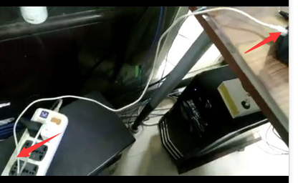

- Use the clip on decoder nipping the chip on board (U22)
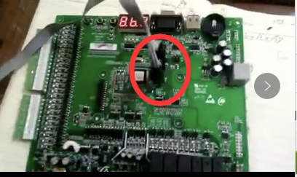
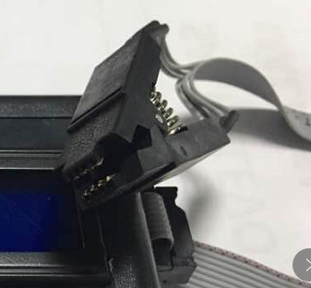

- After connection done, push RED button will show the password:
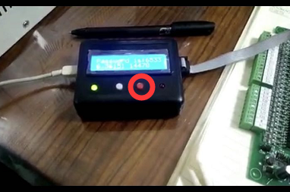

Remark:
Please keep the clip connect the chip and pins on board well, if show the error please check if they didn’t connect good, you could hold it if necessary
