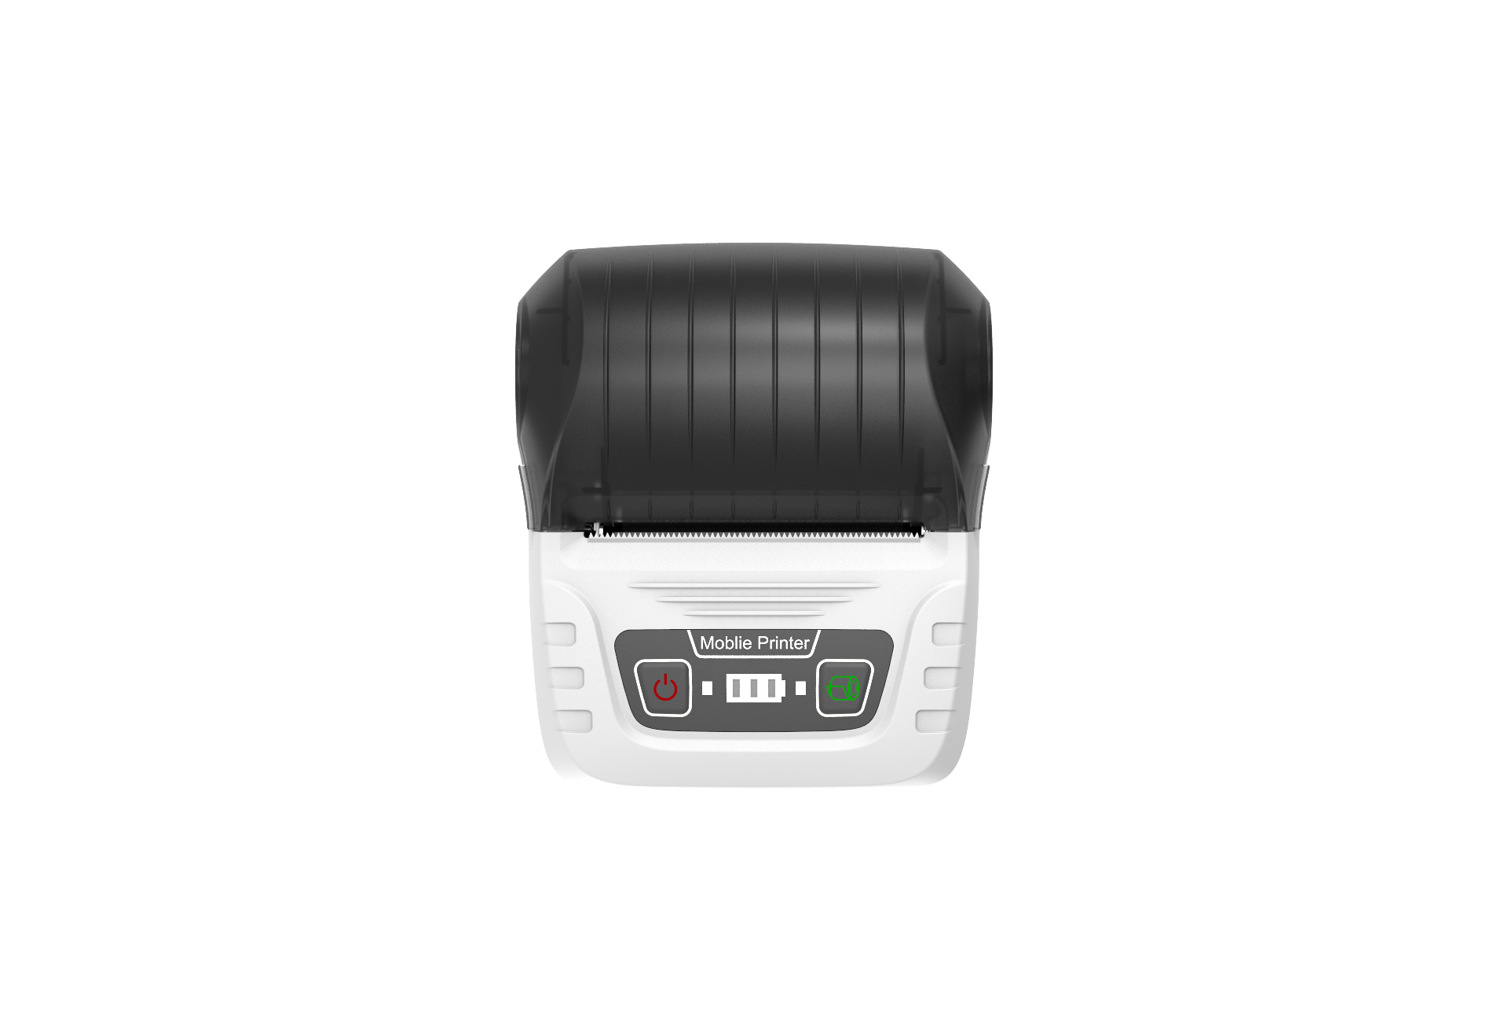

MY58 Mobile printer

project |  | model
parameter name |  | MY58
Printer  data | Print type | Thermal line printer
Printer  data | Fast Print speed | 50mm/s
Printer  data | Resolution | 203dpi
Printer  data | Point distance | 0.125mm
Printer  data | Valid print width | 48mm
Printer  data | Paper | Thermal receipt roll paper, thermal sticker paper
Print material | Paper width | Bill: 58mm Label: 50mm, 40mm, 30mm
Print material | Paper thickness | 0.05-0.18mm
Print material | Paper roll outer diameter | Max 40mm
Print material | Paper loading | Clamshell paper loading, easy loading paper
Print material | Out paper type | Top exit; thermal side facing out
Print material | Cutter type | Plastic tear knife, manual tear off
Print comment | Font English | Height：16， 24
Print comment | Font Chinese | Null
Print comment | Encoding | ASCII；GBK（GB18030 double）；Unicode
Print comment | Print characters | English, Chinese characters, numbers, various symbols
Print comment | Rotation print | 0 degree，90 degree，180 degree，270 degree
Print comment | Bar code | EAN－8、EAN－13、ITF、UPC－A、UPC－E、Code bar、Code93、Code39、Code128
Print comment | 2D bar code | QR Code, PDF417, Data Matrix, Grid Matrix
Print comment | Bitmap | Black and white bitmap (line, curve, table, picture)
Physical characteristics | Machine Size | 101.8mm*86.7mm*48mm
Physical characteristics | Bare metal weight | 188g(Including battery without paper)
Physical characteristics | Package Size | 128.5mm*93mm*53.5mm
Physical characteristics | With package weight | 276g
Physical characteristics | Carton Size | 413mm*303mm*360mm
Physical characteristics | Carton Quantity | 54
Physical characteristics | Carton Weight | 15.5kg
Interactive interface | Input | 2 pc Key button
Interactive interface | Output | Status indicator, battery indicator
Interactive interface | USB Communication Interface | USB-Type-C
Interactive interface | Wireless communication interface | Bluetooth 4.2(SPP+BLE)
Interactive interface | Label detect | Reflective label detection, no virtual slit, label slit >=2mm
Interactive interface | Black mark detect | The middle black mark detection, the black mark is on the printing surface, the position reference picture
Interactive interface | Warning | Out of paper prompt; open cover detection; low battery prompt; overheat prompt
Interactive interface | Command | ESC/POS
Power | Battery capacity | 3.7V 1800mAh Lithium
Power | Battery removable capacity | Detachable
Power | Adapter | Input: AC 100-240V 0.5A，Output：DC 5V1A
Power | Data line | USB-Type-C
Environmental parameters | Operating temperature | 0～50 °C
Environmental parameters | Storage temperature | －20～60°C
Environmental parameters | Operating humidity | 35%～85% No condensation
Environmental parameters | Storage humidity | 10%～90% No condensation
Reliability | Print life | 50Km（1 2.5% Print density）/ 100million pulse
Reliability | Battery lift | 300 cycles of charge and discharge > 60% battery
Reliability | One charge print length | About 100m (12.5% printing density)
Reliability | Certification | CCC
Other data | Print data setup | Use button settings
Other data | Charging time | 4 hours
Other data | Standby time | 60 hours
